Connecting to a Linux Instance Using PuTTY

Step 1: You will first need to get the server credentials for your instance. This can be found on the “My Cloud” page within the Cloud Concierge site. Locate the IP, username, and password.
Note: You can also find this information within the confirmation email that you received from AskIBM Support when your instance completed provisioning. See example below:

Your instance's IP: 159.122.242.56
Expiration Date: August 1, 2017 11:49:05 AM after which the instance will get deleted.
Computer Name: adm121114919.demos.demoibm.com
Name in My Cloud: Base Image – Ubuntu Latest 64
Datacenter: dal10
Instance ID: 12345678
OS Username: ibm
OS Password: IBMDem0s!
Use default RDP port 2222.
Step 2: On your Windows desktop, click the Start button and type “putty” in the search bar.
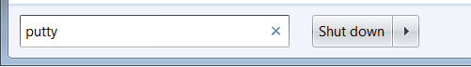

Step 3: Click on ‘PuTTY’ when the results appear.
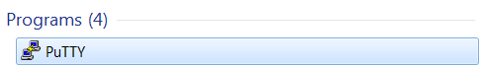
Note: If no results are returned, then you must install PuTTY to your computer. This is a free open source program that can be downloaded via ISSI, or from http://www.putty.org/

Step 4: Fill in the appropriate IP address as well as the port number shown below and click ‘Open’
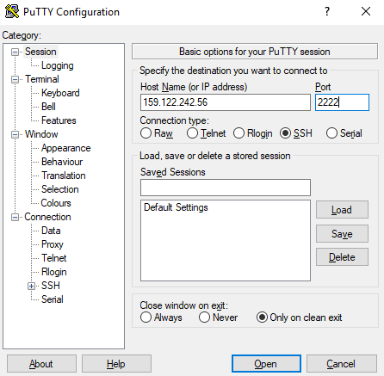
Note: Your instance may require an additional step to accept a security key. Click Yes.
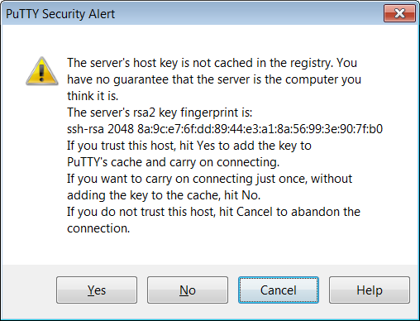
Step 5: You will now be required to enter the credentials for your instance. Click Enter after entering the username/password to logon to your instance.
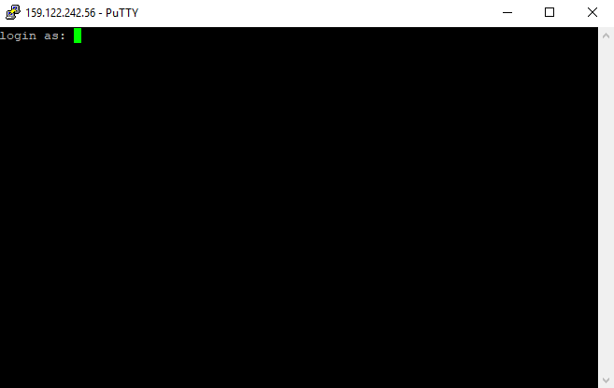
Step 6: The demo will now be connected to the Linux terminal.
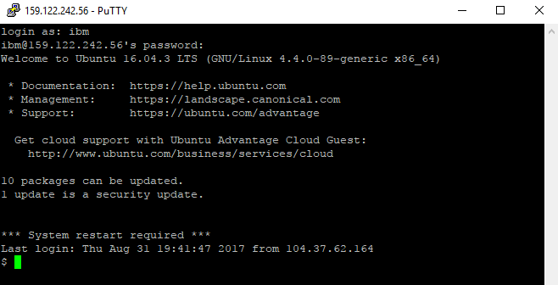

Troubleshooting Tips
Reminder: These instructions are for Windows users. If you are on a Mac, please visit the Cloud Concierge support page for Mac instructions.
Startup Issues: Occasionally your instance will not fully load all services and prevent access to your instance. Reboot the instance in your ‘MyCloud’ page, wait 10 minutes, then try to log in again.
SoftLayer VPN: Some instances will require SoftLayer VPN security. If this is the case, then the IP Address will begin with a “10.x.x.x”. You will first need to login to a SoftLayer VPN session to access the instance. Please see the Cloud Concierge support site for instructions on connecting to SoftLayer, or click the link below if you have an existing account.
http://www.softlayer.com/VPN-Access

PuTTY Issues: Your firewall or network may be blocking PuTTY or the port needed to use this application. Follow the troubleshooting steps to resolve:
- If you provisioned a Private Instance, you will first need to connect to the SoftLayer VPN
- Be sure you can ping the IP address to ensure your computer can see the system.
- Ensure you are using the correct PuTTY port (check your My Cloud/email confirmation).
- Try using a public internet connection.
- If you are using IBM LEAP WiFi, turn your WiFi off and use an Ethernet cable.
- Check to see if a peer on the same network can ping and/or PuTTY to your system.
- Try a different computer on a different network, such as a home computer.
- On your PC, turn off Symantec or Windows firewall.
- Visit the My Cloud webpage, choose your system, obtain the Private IP of your system, VPN into SoftLayer, and return to Step 2.
Note: If you still need more help, you can reference the Network Troubleshooting guide on the Cloud Concierge Support website, or send an email to Cloud Concierge support at:
askibmst@ca.ibm.com

